Smart Speaker Basics
Steve Kelley, CVRT,CRC, CATIS
skelley@theiris.org

- Digital assistants are software or artificial intelligence, and may be on different devices. For example, you can find Alexa, the digital assistant on the Amazon Echo, Kindle Fire, in the Alexa app on an Android, etc.
- Smart speakers are pieces of hardware that contain a microphones, speakers, and a digital assistant:

  - Amazon Echo
  - Amazon Dot
  - Google Home
  - Google Home mini
  - Apple Home Pod
  - Sonos One with Alexa and Google coming
  - JBL with Google Assistant
- All speakers require wifi network and public wifi networks do not seem to work well or at all

Unique Features of the digital assistants
Apple Siri
- HomePod is great speaker
- For the Apple world only
- Very limited outside the Apple world
- Unique setup
Google Assistant
- Native to Google Home and Google Home mini
- Can call a number based on a request, “Call the Iris Network on Park Ave in Portland.”
- Phone calls by contact or number
- Conversational questions
- Google Play Books
- Choice of voices male/female; at least one is slower in rate than the others
- Currently plays radio stations on TuneIn but not podcasts
Amazon Alexa
- Native to Amazon Echo line
- Book reading includes some Kindles and Audible
- Text messages
- Phone calls by number or contact

Tunin Content Available on Amazon Echo and Google Home

Free Audio Book of the Month Podcast

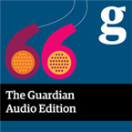

Guardian Audio Edition

Radio Reading Services

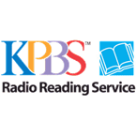

KPBS Radio Reading Service
Column One

Down East Radio Reading Service
US

WKAR RRS
US

Owl Radio
Reading for those who cannot see

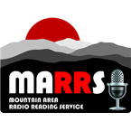

Mountain Area Radio Reading Service
Asheville News

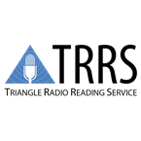

Triangle Radio Reading Service
We breathe words into your life

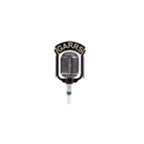

GaRRS
Serving All Of Georgia

Print Radio Tasmania
Turning Print Into Sound

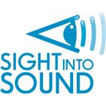

Sight into Sound radio reading service
Turning Sight into Sound

The Sight Seer Radio
Audio for Independent Living

Goodwill Easter Seals Miami Valley Radio Reading Service
US

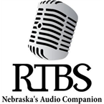

Radio Talking Book Service
Nebraska's Audio Companion

WJCT Radio Reading Service
WJCT. Your Community. Your World.

CRIS Radio/Windsor
Audio Access for People Who Are Blind or Print-Challenged

IOWA Radio Reading Information Service
Des Moines, IA

WQCS Radio Reading Service
US

Voicecorps radio
Audio Access to the World

CKRE
Seeing the world through the voice of another

Northeast Radio Reading Service
US

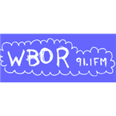

WBOR
Peach Fuzz

Radio 1RPH
Turning Print into Sound

Audio Journal
An Affilate Of TIC Network

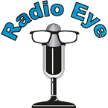

Lexington Radio Eye
Your Eye on the Written World

Eastern Kentucky Radio Eye
Your Eye on the Written World

Louisville Radio Eye
Your Eye on the Written World

Morehead Radio Eye
Your Eye on the Written World

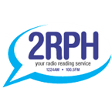

2RPH
Sydney's Radio Reading Service

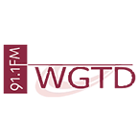

WGTD-HD3
Community Radio for Kenosha & Racine

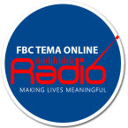

FBConline Radio
Making Lives Meaningful

4RPH
Bringing the printed word to life!

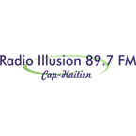

Radio Illusion 89.7 FM
We love hearing from your all fans Illusion fm 24/7

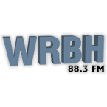

WRBH
Reading Radio For The Blind And Print Handicapped

Minds Eye
Sight Becomes Words

Smart speakers, like the Amazon Echo and Google Home can bring a great deal of information, practical communication functions, and leisure to older adults, without the need for a computer science degree or even a keyboard. Explore the basics and some features of each to consider during an assessment.

